

**Software Engineering Department**

**Braude Academic College**

**Capstone Project Phase A – 61998**

**Enhancing handwriting using graphic tablet**

**23-1-D-11**

**Sender Hodik, Idan Brauner**

[**senderh55@gmail.com**](mailto:senderh55@gmail.com)

[**idann79@gmail.com**](mailto:idann79@gmail.com)

**Supervised by Dr. Anat Dahan and Dr. Navit Roth**

Table of Contents

1. Abstract 3

2. Introduction 3

3. Background 4

3.1 The importance of improving handwriting at an early age 4

3.2 Dysgraphia 4

3.3 Occupational Therapist 6

3.4 Handwriting parameters 7

3.4.1 Handwriting speed 7

3.4.2 Handwriting orientation 7

4. Related works 8

4.1 Occupational Therapy Intervention on Handwriting 8

4.2 handwriting tracing worksheet 8

4.3 Handwriting Without Tears 9

5. Expected Achievements 10

5.1 Outcomes 10

5.2 Unique Features 10

5.2.1 Real-time Unique feedback response system 10

5.2.2 Conversion of handwriting to screen and calculation of writing distance 10

5.2.3 Hebrew language support 11

5.2.4 Using a Web Interface 11

5.3 Success Criteria 11

6. Research and Engineering Process 11

6.1 Process 11

6.2 Graphic Tablets 13

6.2.1 Wacom Tablets 13

6.2.2 Wacom Intuos Pro 13

6.2.3 Graphic Tablets and Education 14

6.3 Analyzing pen location to detect writing coordinates on screen 14

6.4 Product 15

6.4.1 The Main Algorithm - writing practices 15

6.4.2 User management system 17

6.4.3 Diagrams 17

6.4.4 Model-View-Controller (MVC) pattern 23

7. Evaluation and Verification Plan 25

7.1 Evaluation 25

7.2 Verification 25

References 29

## 1. Abstract

Handwriting is an essential skill used in building self-esteem, academic achievement, accessible creativity, artistic opportunities, and daily task. Many children struggle with handwriting despite the fact that it is a necessary skill for academics and other professions. As a result, there are occupational therapists who are skilled in helping children improve their handwriting.

Since technology has advanced, development of advanced digital technologies may offer fresh and newer ideas from the traditional methods like pencil and paper that are no longer efficient enough.

We are developing a web-based system to improve handwriting using graphic tablets for occupational therapists who work with elementary school children. As part of our project, we designed an integrated software and graphic tablet system to provide a convenient and engaging platform for handwriting practice, as well as provide real-time feedback, while addressing specific parameters such as writing alignment, orientation, and speed, for the patient and the therapist.

You can find the project code at the following link:

<https://github.com/senderh55/enhancing-handwriting-project>

## 2. Introduction

Handwriting is the process of writing by hand, typically with a pen or pencil on paper. As the user must manually control the movements of their hand and fingers to produce written language. Handwriting is an important skill for children to learn, as it is a fundamental component of literacy and education. It is also important for adults to maintain good handwriting skills, as it can improve productivity and legibility. Some common challenges with handwriting include difficulty forming letters, illegible writing, and slow writing speed.

Dysgraphia is one of the examination disabilities of handwriting since it affects the ability to produce written language. It is often characterized by difficulties with spelling, handwriting, and composition. People with dysgraphia may also have trouble organizing their thoughts on paper and may struggle with grammar and punctuation. Dysgraphia can be a result of several different underlying causes, including neurological disorders, developmental delays, and damage to the areas of the brain that control language and writing.

In general, poor handwriting is treated with a combination of educational support, such as specialized instruction and assistive technology, as well as occupational therapy to improve fine motor skills.

The purpose of our project is to help primary school children who are suffering from poor handwriting from various circumstances improve their handwriting as much as possible by using interactive software, and an interface that is friendly and not boring for them and that focuses on the Hebrew language.

It is both our personal experiences with handwriting difficulties from a young age that motivated us to develop this idea clearly

Once we decided on the subject for the project, we contacted several professionals. As we searched, we found that the Hebrew language does not have enough satisfactory solutions, so we considered how to solve this problem

To In order to meet our challenge, we need a combination of hardware and software. Hance, we integrate our software with a graphic tablet that measures pen position, with allows the software to respond accordingly.

## 3. Background

This section examines concepts related to writing difficulties, treatment methods, and their importance while discussing specific parameters and tools that help with these challenges.

### 3.1 The importance of improving handwriting at an early age

Improving handwriting at an early age can have a number of benefits for children. Here are a few reasons why it is important:

1. Handwriting is an important skill for academic success. Many children in the early grades are required to write by hand for assignments and tests. Children with good handwriting are more likely to be able to complete these tasks quickly and legibly, which can lead to better grades.[1]
2. Handwriting can improve fine motor skills. Handwriting involves using small muscles in the hands and fingers to control a writing instrument. Improving handwriting can help children develop these fine motor skills, which can have a range of benefits, including improved dexterity and coordination.[2]
3. Handwriting can support language development. Writing by hand can help children learn to spell and write new words, which can support language development and literacy skills. [3]
4. Handwriting can boost self-esteem and confidence. Children who are able to write neatly and legibly may feel more confident and prouder of their work, which can improve their overall self-esteem. [4]

Overall, improving handwriting is an important skill that can have a positive impact on children's academic and personal development.

### 3.2 Dysgraphia

Dysgraphia is a neurological condition that causes someone to have difficulty putting their thoughts into written form for their age and ability to think, regardless of what instruction and education they have received. A person suffering from dysgraphia may experience many different symptoms depending on the stage of the disorder. An individual with this condition is considered to have a learning disability.

There are many skills and brain functions involved in writing, including: fine motor skills, spatial perception, working memory, orthographic coding, working memory, language processing, organization, etc. Because of this, dysgraphia is somewhat of a catch-all term to diagnose issues with writing and can be difficult to diagnose.

The first sign of dysgraphia usually appears when children are learning to write. Developmental dysgraphia is characterized by this behavior. It is also possible for people to develop dysgraphia suddenly after a head or brain trauma. This is called acquired dysgraphia.

Dysgraphia is considered a specific learning disorder or a “specific learning disorder in written expression.”

Dysgraphia can affect regardless of age and is more common in males. the chance of developing dysgraphia is higher when there are family members suffering from this disorder. Also, dysgraphia is common in children with autism spectrum disorder (ASD) and/or attention deficit hyperactivity disorder (ADHD). Dysgraphia can present its symptoms in several ways, and dysgraphia sufferers may have difficulty writing as well as speaking. These are some aspects they may be struggling with:

● Letter formation and/or legibility.

● Letter size and spacing.

● Spelling.

● Fine motor coordination.

● Rate or speed of writing.

● Grammar.

● Composition

The following are some examples of how dysgraphia can present itself

● Difficulties writing in a straight line.

● Difficulties with holding and controlling a writing tool.

● Writing letters in reverse.

● Having trouble recalling how letters are formed.

● Having trouble knowing when to use lower or upper-case letters.

● Struggle to form written sentences with correct grammar and punctuation.

● Omitting words from sentences.

● Incorrectly ordering words in sentences.

● Using verbs and pronouns incorrectly.

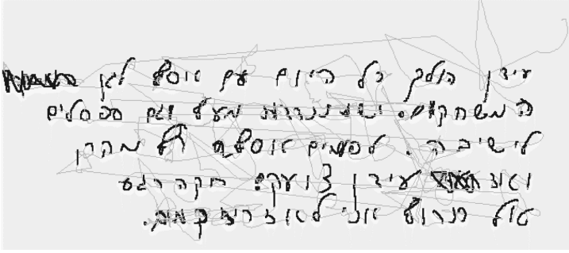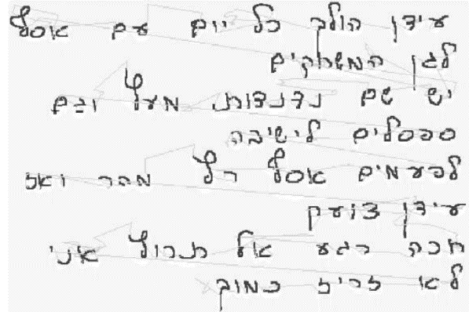

Figure 1. Handwriting samples of a paragraph copying of a typical proficient (left) and a typical dystrophic handwriting (right) [5]

Despite being included in the “specific learning disorder” category of the Diagnostic and Statistical Manual of Mental Disorders 5th edition (DSM-5), dysgraphia is not defined as a separate disorder, and its diagnosis is not based on any specific criteria. Due to these reasons, dysgraphia can be difficult to diagnose - but not impossible.[12]

In an educational setting, dysgraphia is typically diagnosed using a team assessment that includes these specialists:

● Occupational therapists.

● Physical therapists

● Special education teachers.

● Educational psychologists.

● Speech therapists.

* Neuropsychologists

### 3.3 Occupational Therapist

Occupational Therapist is an authoritative healthcare professional offering support to people with physical, psychological, and social problems to enable them to live life to the fullest. Occupational therapists help people to do the everyday activities they want and need to do when faced with illness, injury, disability or challenging life circumstances or events.[6] There is a difference between occupational therapy and physical therapy, which often work together as a team. Physiotherapists help people restore physical function; occupational therapists focus on how that function affects the ability to do the things that are important to them.

As an example, occupational Therapy works with children and teachers in a classroom to help children develop skills such as handwriting or computer use or to provide strategies to manage behavior – skills that will make it easier for students to learn and thrive in school.

### 3.4 Handwriting parameters

Handwriting refers to the style in which a person writes using a pen or pencil. Some of the parameters that can be used to describe handwriting include:

* Slant: Handwriting can be upright (with little or no slant to the right or left) or slanted (leaning to the right or left).
* Size: Handwriting can be large or small in size.
* Pressure: The pressure with which a person writes can affect the appearance of the handwriting. Light pressure can result in thin, faint lines, while heavy pressure can result in thicker, darker lines.
* Spacing: The space between letters and words can vary in handwriting. Some people may have closely spaced handwriting, while others may have more widely spaced handwriting.
* Connections: Some letters may be connected in handwriting, while others may be written separately.
* Fluidity: Handwriting can be smooth and fluid or choppy and jerky.
* Legibility: Handwriting that is easy to read is considered to be legible, while handwriting that is difficult to read is considered to be illegible.
* Penmanship: The overall quality and appearance of handwriting is referred to as penmanship. Good penmanship is often characterized by clean, neat, and well-formed letters

The practices will be based on those parameters include, among others, the following:

#### 3.4.1 Handwriting speed

Handwriting speed refers to the rate at which a person is able to write by hand. This can be measured in words per minute (wpm) or in characters per minute (cpm). Factors that can affect handwriting speed include the individual's level of proficiency in writing, their writing implement (pen, pencil, etc.), the surface they are writing on, and their physical ability to move their hand and fingers. Some people may have naturally faster handwriting speed, while others may need to practice and improve their speed over time. Handwriting speed can be important for things like taking notes, writing exams, or completing written assignments quickly and efficiently.

#### 3.4.2 Handwriting orientation

Handwriting orientation refers to the direction in which a person writes. In most Western countries, people are taught to write from left to right, starting at the top of the page and moving down. This is known as a left-to-right orientation. However, some people may have a different writing orientation, such as right-to-left or top-to-bottom. The orientation includes accuracy to maintain the writing between the specific border of the line and from where to start the writing of a letter and where to end it. person orientation writing can be influenced by their native language, cultural background, and personal preference. It's important for people to be able to read and write in the standard orientation for their language in order to be able to effectively communicate with others. Researchers have found a link between organizational skills and handwriting performance, which is an important point to note. [7]

## 4. Related works

A number of examples are provided below to illustrate the importance of handwriting improvement

### 4.1 Occupational Therapy Intervention on Handwriting

Patients come to occupational therapy to improve their handwriting. Parents and teachers are often frustrated by children's poor handwriting, which can be a source of frustration. As a complex task requiring coordination between the eyes, hands, and brain, handwriting requires a lot of effort. Any of these components may be difficult for a child, leading to poor pencil grip, inaccurate or slow letter formation, or inconsistent spacing between words. Academic performance and self-esteem can suffer if handwriting difficulties go unaddressed. In schools, occupational therapists can provide students with assistance in improving their handwriting.

Fine motor skills are essential to successful handwriting, and occupational therapists can help children develop these skills through individualized assessment and targeted interventions. Thus, the recommendation of an occupational therapist may be an important first step toward a child's full potential.

Occupational therapy for handwriting significantly benefits school students in the early grades, according to studies. In her research on the topic, Jane Case-Smith found significant increases in in-hand manipulation and position-in-space scores. Additionally, School students improved their handwriting legibility scores more than those in the comparison group.[8]

### 4.2 Handwriting tracing worksheet

A handwriting tracing worksheet is a sheet of paper with lines or shapes on it that a person can use to practice writing letters or numbers. The lines or shapes provide a guide for the person to follow as they write, helping them to form the letters correctly. Handwriting tracing worksheets are often used by children as a way to learn how to write, as well as by adults who are learning a new writing system or who want to improve their handwriting. Some tracing worksheets may also include pictures or words to trace, as well as blank lines for the person to write on their own. Handwriting tracing worksheets can be found in many places, such as in schools, online, or in stores that sell educational materials.

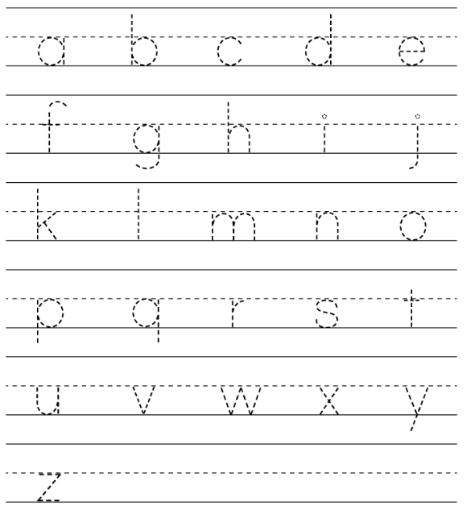

Figure 2. Handwriting tracing worksheet for English letters [13]

### 4.3 Handwriting Without Tears

Handwriting Without Tears is a program designed to teach children how to write. The program was developed by Jan Z. Olsen, an occupational therapist, and is based on research and years of experience working with children. Handwriting Without Tears uses a multi-sensory approach, incorporating visual, tactile, and kinesthetic elements to help children learn how to form letters correctly. The program includes a variety of materials, such as worksheets, games, and manipulatives, that are designed to be developmentally appropriate for children of different ages and abilities. The goal of Handwriting Without Tears is to help children learn to write quickly, and legibly, so that they can focus on the content of their writing rather than the mechanics of forming letters [10]

*This method available only in English handwriting.

## 5. Expected Achievements

### 5.1 Outcomes

An interactive handwriting improvement system that trains the fundamental basis of writing which expected to achieve several key outcomes. One of the primary goals of such a system is to help users improve their handwriting skills and accuracy. This may involve providing feedback and guidance on proper handwriting. Another key outcome of an interactive handwriting improvement system is the ability to adapt to the specific needs and abilities of each user. This may involve customizing types of exercise based on the therapy recommendations.

In addition to improving handwriting skills, an interactive handwriting improvement system is also expected to enhance the overall user experience. This may involve providing a seamless and intuitive interface for users to input and interact with handwritten text and symbols, as well as incorporating elements such as games and other interactive features to make the learning process more engaging and enjoyable.

Overall, the implementation of an interactive handwriting improvement system in Hebrew is expected to result in significant improvements in handwriting accuracy and skills, as well as a more enjoyable and engaging learning experience for users

### Unique Features

#### 5.2.1 Real-time Unique feedback response system

One of the main benefits of using a graphic tablet is the real-time response that they offer. When a user writes or draws with a pen on a graphic tablet, the input is transmitted to the computer in real-time, allowing the user to see their work on the screen as they create it. This can be a more intuitive and responsive way to work compared to using a mouse or trackpad.

In our software we include symbols on correct or incorrect actions from the user, to encourage him or correct him.

For example, deviation from lines that are the borders which are the correct size to writing on the page.

#### 5.2.2 Conversion of handwriting to screen and calculation of writing distance

The system involves converting what's written on the graphic tablet to the computer screen, so it's important to have the screen borders aligned with the tablet so the user knows where he's writing. With this goal in mind, the system will calculate the centimeters and pixels in order to provide a complete answer.

In addition, the organization handwriting practice, which is extensively described in the product section, requires dividing the page into segments for proper organization. A dynamic parameter will be adjusted based on the inputs of the user, and a distance between screen points will be calculated to enforce the transition between the segments.

#### 5.2.3 Hebrew language support

One of the main focuses of our project is to give digital interaction exercises to our native language (Hebrew) and by that cover a field that didn't exist until now.

#### 5.2.4 Using a Web Interface

A web-based interface is a type of interface that allows users to access and interact with a website or online application through a web browser. Web-based interfaces are typically accessed over the internet, and do not require the user to install any special software or applications on their device.

One of the key benefits of web-based interfaces is that they are accessible from any device with an internet connection and a web browser, making them highly portable and convenient to use. They also allow developers to update and improve the interface quickly and easily, without requiring users to download and install new software.

Part of our web-based interface for user management will include storage, analysis, and presentation of specific data for each user that is established and regularly updated according to his previous products.

### Success Criteria

1. A product that can be used as a good interactive handwriting tool for occupational therapy or personal use.

2. To introduce an original technological tool that will form the basis of future innovations in the field.

3. Intuitive and easy-to-use web user interface with graphics tablets full integration.

4. An easy and enjoyable activity experience for the user suitable for children.

## 6. Research and Engineering Process

### 6.1 Process

Our engineering process began with brainstorming with an aspiration to characterize difficulties we experienced from a young age and to be able to offer them a technological solution, focusing on the medical psychological aspect.

After finding that we both had difficulties with writing, we began to delve into this topic.

We realized that the subject consists of many fields and we decided to publish a post on Facebook in an occupational therapy group that includes a survey, in order to receive help and guidance from professional sources in the field.

As a response to the post, we received a referral to Prof. Sarah Rosenblum, chair of the doctoral program in the Department of Healing and Occupation at the University of Haifa. We contacted Prof. Rosenblum who directed us to studies that clarified which subfield of the manuscript we should focus on, diagnosis or treatment.

After the review of the studies and a referral from Prof. Rosenblum to Dr. Navit Roth from the mechanical engineering department at Braude Academic College, with whom she did an in-depth study on hand tremors. We shared our findings with our supervisor, Dr. Anat Dahan, who joined us as a co-supervisor.

With the help of Navit and Anat's guidance, we made contact with an occupational therapist named Ms. Romi Mirenburg who helped us focus on a technological solution that would support the treatment of writing difficulties while focusing on three main parameters - speed, organization and directionality.

The next step was to define the requirements for our system. At first, we had to envision how our system will be visualized and what hardware would be needed to show handwriting on a screen. We also investigated the handwriting process, challenges, and existing treatments.

The method for getting inputs from our graphic tablet and transferring them to the browser was discussed. During this process, we planned our basic algorithm and the functionality of our system. An architecture scheme was created then followed by use case diagrams and flowcharts.

As soon as we had gathered most of the information we needed about our system, we began designing the prototype (based on all the information we had collected) and planning the testing.

Based on our progress and the semester, we realized that we need to learn new software environments and programming languages to overcome the following challenges:

* The project is built on JavaScript: the front-end is built using the React library, and the back-end is built using the NodeJS runtime environment.
* Using the p5.js library will help us create interactive and graphic experiences.
* The Jest framework for JavaScript testing should be used to ensure the quality of our JavaScript codebase.
* In order to increase the number of safe and secure ways for our users to sign up, we now offer Google Sign-In services.
* AWS - Amazon Web Services - is the main cloud computing service we'll use throughout our software, including EC2 and S3 storage. With these services we can deploy, maintain, and provide support for our application.
* Our database will store user data and properties, such as personal details and information for the related work. For that, we will use MongoDB, a no-SQL database that integrates well with NodeJS.

We will begin writing our software using our plans and models as we proceed through the next steps of our development process.

### 6.2 Graphic Tablets

Graphic tablets, also known as pen tablets or drawing tablets, are input devices that are used to capture digital images. They consist of a flat, pressure-sensitive surface, on which the user can draw or write using a special pen or stylus. Graphic tablets are commonly used by artists and designers to create digital artwork and are also used in a variety of other applications, such as handwriting recognition and data entry. Unlike a traditional mouse, which only has two degrees of freedom (x and y movement), a graphic tablet allows the user to capture pressure and tilt information, which can be used to create more natural and realistic digital drawings.

#### 6.2.1 Wacom Tablets

Wacom is a brand of graphic tablets that are widely used by artists, designers, and other creative professionals. They are known for their high-quality, pressure-sensitive surfaces, which allow for precise control and a natural drawing experience. Wacom tablets are available in a range of sizes and styles, from small, portable models that can be used on the go, to larger, more feature-packed models that are designed for use in a studio setting. Wacom tablets can be connected to a computer via USB or Bluetooth, and are compatible with a wide range of creative software, including Adobe Photoshop and Illustrator.

#### 6.2.2 Wacom Intuos Pro

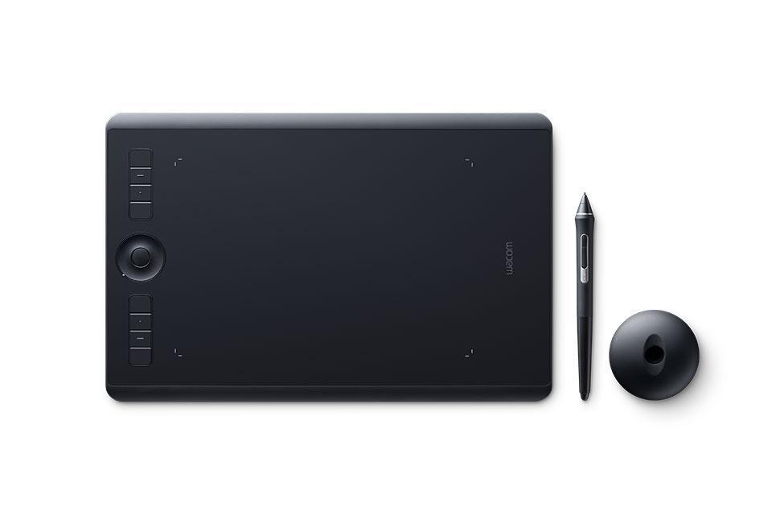The Wacom Intuos Pro is considered to be one of the best graphic tablets on the market and is widely used by professional artists and designers.

*Figure 3. Wacom Intuos pro [11]*

The Wacom Intuos Pro version can attach a paper that is a variant of the regular Wacom Intuos Pro graphic tablet that comes with a special paper clip, which allows the user to draw on paper and have their work digitized in real time. The paper clip attaches to the edge of a piece of paper, and uses a combination of sensors to track the position of the pen on the paper. This allows the user to draw on paper as they normally would, and have their work automatically converted into a digital format and saved to their computer.

#### 6.2.3 Graphic Tablets and Education

Graphic tablets can be a useful tool in education, as they can provide a more natural and intuitive way for students to interact with digital content. In art and design classes, for example, students can use graphic tablets to create digital artwork, which can be more engaging and expressive than using a mouse or trackpad. In subjects like math and science, students can use graphic tablets to write and manipulate equations, diagrams, and other graphical elements in a way that is similar to working with pencil and paper. In addition, graphic tablets can be used in a variety of other educational contexts, such as language learning and handwriting recognition. Overall, research suggests that graphic tablets can be a valuable educational tool, and can provide students with a more engaging and interactive learning experience.



Figure 4. Example of how a graphic tablet can be used in learning environment [14]

### 6.3 Analyzing pen location to detect writing coordinates on screen

It is possible to use a graphic tablet to detect the coordinates of a pen as it moves across the surface of the tablet. This can be done by using a stylus or other pointing device that is equipped with sensors that can track the movement of the pen. The coordinates of the pen can then be transmitted to a computer or other device in real-time, allowing the device to track the movements of the pen and display them on the screen

It is necessary to use software capable of receiving and processing the pen coordinates as it moves across a graphic tablet's surface in order to analyze the pen location. An application specifically designed to track and analyze pen movements could be used, such as a handwriting recognition program, art software, or drawing and painting software.

### 6.4 Product

#### 6.4.1 The Main Algorithm - writing practices

Rather than the cumbersome treatment process that exists today, we are interested in creating a visual interface that makes the treatment process more enjoyable.

Since both of us have a programming training background, we recognized that graphic libraries are able to illustrate graphics on the screen in an intuitive and comfortable manner.

Among the programs, there is a p5.js library, which is described as follows: “p5.js is a JavaScript library for creative coding, with a focus on making coding accessible and inclusive for artists, designers, educators, beginners, and anyone else!” [9]

This graphic library has a unique draw function that allows the drawing to run continuously and be dynamic. Therefore, additional illustrations can be added and react in real time to events.

For our case, the graphic tablet can be used in conjunction with the p5.js library to create interactive drawings and animations.

The tablet typically connects to the computer via USB and allows the user to draw on the tablet surface using a stylus, while the p5.js library captures the coordinates of the stylus and converts them into digital drawings on the computer screen.

Additionally, the p5.js library can be used to apply various effects and transformations to the digital drawings, such as color, size, and rotation. This allows for a more natural and intuitive drawing experience compared to using a mouse or trackpad.

Aside from user and information management, the core of the system will revolve around this library, which includes two practices:

* **Letter Practice:**

The user can replace the manual method of tracking pages this option, the user will be able to select a specific letter from the Hebrew alphabet (“print” letters, endings included).

Following the selection, of one of the letters, the user will see a page with lines including that letter on it.

An example of one of the letters can be seen in the figure below, and the user must complete the letter in its identical form and order, which can be done by rewriting according to its size and orientation.

The user will have to follow the marked letters in the correct order. In addition, real-time feedback will be given for his actions, including selecting the letter, directional tests, and letter marking (based on comparison of the input coordinates with the letters' positions on the screen).

A feedback example is alerting the user when he selects a letter to rewrite but it's not in the correct order.

Selections that are not in their correct order will be highlighted with an arrow and an indication of where the user should continue

Figure 5. An example of an effective letter writing tutorial

* **Handwriting organization practice**

Handwriting organization practice is based on the concept that a patient should maintain the correct order on the page. In our case - the Hebrew language - we write from the top to the bottom. As we described in the background chapter, organizational ability and writing correctly are closely related.

As a part of the practice, the page will be divided into segments according to the user's decision when the parameter is the gap between two writing points. A user input parameter will also determine the minimum percentage of writing in a line before moving on.

In the same way as training letters, there will be real-time feedback provided if there is a deviation from the line, along with checking in real time whether the writing was completed in segments based on priority.

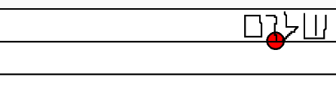

Figure 6. Feedback on deviations from the line with relevant position

Since the rate of writing is an important measure, we will use a timer during practice to measure the rate of writing, so the user can see and control his progress.

Data will be collected at the end of each practice - the time, the number of errors, and a screenshot. Users will be able to view all of these throughout their use of the system.

#### 6.4.2 User management system

The user management system allows registered users to view their own profiles for tracking their practices

Our system would allow users to create and manage multiple profiles, and each profile would have access to the practices. These profiles could contain data such as personal data and practice results

Additionally, the system could also provide the ability to track progress and performance of users and profiles associated with them, and provide detailed reports on their performance

In such a user management system, users -therapists can monitor patients' progress in a centralized and organized manner

#### 6.4.3 Diagrams

**Use Case diagram**

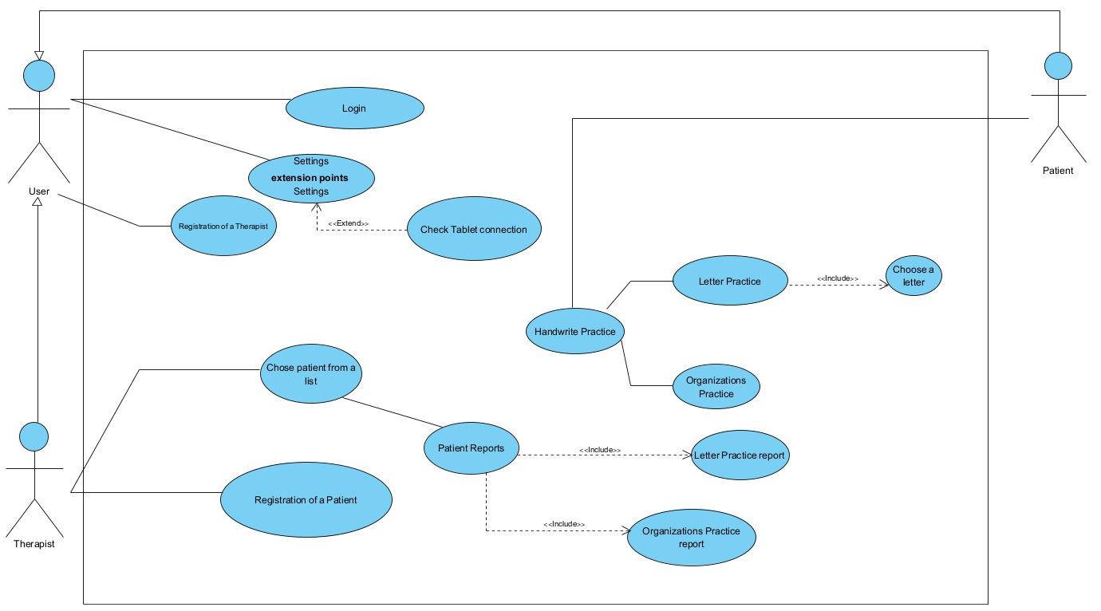

|  |  |
| --- | --- |
| Use Case | Login |
| Description | Creating and showing achievements report |
| Actors | User |
| Triggers | The user presses “Login” button |
| Initial Conditions | The user is registered into the system |
| Successful Scenario | 1. **The System** shows personal details form 2. **The User** enters email and password. 3. **The User** presses “Login to your account” button. 4. **The System** checks input accuracy. 5. **The System** checks input in the database. 6. **The System** loads the home page. |
| Alternative Scenarios | 4.1 **The System** marks the illegal data Move back to step 4.   * 1. **The System** encounters a problem when loading the data.   **The System** shows the user an error page. |

|  |  |
| --- | --- |
| Use Case | Settings |
| Description | Changing setting for the game |
| Actors | User |
| Triggers | The User finished login process |
| Initial Conditions | The User is registered into the system |
| Successful Scenario | 1. **The System** shows the Login screen. 2. <<extend>> **The User** clicks the “Check Tablet connection” button. |
| Alternative Scenarios |  |

|  |  |
| --- | --- |
| Use Case | Registration of a therapist |
| Description | Creating a new therapist account in the system |
| Actors | User |
| Triggers | User presses on “Registration of a therapist” |
| Initial Conditions | The user does not have an account |
| Successful Scenario | 1. **The System** shows personal details form 2. **The User** enters personal details, email and password. 3. **The System** checks input accuracy 4. **The User** press “save” button 5. **The System** saves those details and creates a new account 6. **The System** shows confirmation to the user. |
| Alternative Scenarios | 3.1 **The System** marks the illegal data Move back to step 3.   * 1. **The System** encounters a problem when saving the data   **The System** shows the user an error page. |

|  |  |
| --- | --- |
| Use Case | Patient Reports |
| Description | Creating and showing Patient report |
| Actors | Therapist |
| Triggers | The Therapist presses “Patient Reports” button |
| Initial Conditions | The Patient is registered into the system |
| Successful Scenario | 1. **The System** shows the creating Patient report screen 2. **The Therapist** chooses: Letter Practice report or Organizations Practice report. 3. **The System** generates the report and shows it. |
| Alternative Scenarios | 3.1 **The System** shows a message if there is no report to show for the selected filters. |

|  |  |
| --- | --- |
| Use Case | Registration of a patient |
| Description | Creating a new account in the system |
| Actors | Therapist |
| Triggers | Therapist presses on “Registration of a patient” |
| Initial Conditions | The user does not have an account |
| Successful Scenario | 1. **The System** shows personal details form 2. **The User** enters personal details, email and password. 3. **The System** checks input accuracy 4. **The User** press “save” button 5. **The System** saves those details and creates a new account 6. **The System** shows confirmation to the user. |
| Alternative Scenarios | 3.1 **The System** marks the illegal data Move back to step 3.   * 1. **The System** encounters a problem when saving the data   **The System** shows the user an error page. |

|  |  |
| --- | --- |
| Use Case | Handwrite Practice |
| Description | Patient is starting handwrite practice |
| Actors | Patient |
| Triggers | The Patient/Therapist presses “Handwrite Practice” |
| Initial Conditions | The patient is registered into the system |
| Successful Scenario | 1. **The System** shows the practice screen 2. <<include>> **The User** chooses a practice between letter practice from the Hebrew Alphabet or sentence practice. 3. **The Patient** plays the practice 4. **The System** shows a success page at the end of the level |
| Alternative Scenarios | 4.1 **The System** shows a failure page at the end of the level. |

**Requirements**

|  |  |  |
| --- | --- | --- |
| **Requirement Number** | **Requirements** | **Classified Requirement** |
| 1.1 | System will enable user to produce report on the practices. | FR |
| 1.2 | The therapist is able to look at a report using the system. | NFR |
| 2.1 | The system work with graphic tablet hardware to insert patient handwriting. | FR |
| 2.2 | The handwriting can be insert to the system using a graphic tablet. | NFR |
| 3.1 | The system will allow a registration of new user to the database. | FR |
| 3.2 | Only the therapist is the one who can register a patient. | NFR |
| 4 | The system will display visual data according to the report of the practices. | FR |
| 5 | The system will provide real-time feedback to correct/Incorrect handwriting. | FR |
| 6 | Newer Wacom Intuos Pro versions are also supported. | NFR |

**Activity diagram**

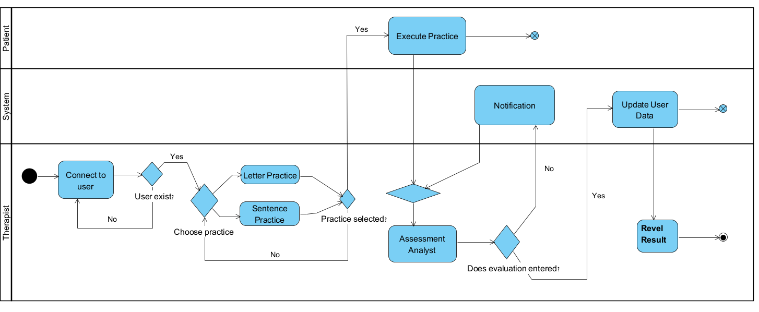

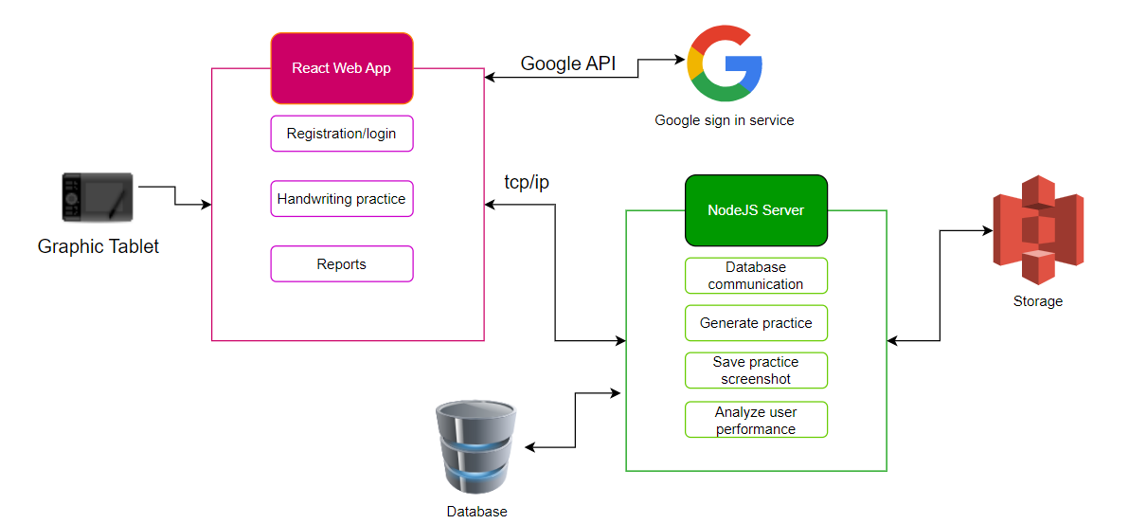**Project architecture**

#### 6.4.4 Model-View-Controller (MVC) pattern

Software architecture patterns refer to a set of established practices and solutions for designing and structuring software systems. These patterns are designed to address common problems and challenges that arise in the software development process, such as scalability, maintainability, and reusability. Some common software architecture patterns include the Model-View-Controller (MVC), the Model-View-ViewModel (MVVM), and the Model-View-Presenter (MVP) pattern.

Each of these patterns follows a specific set of guidelines to separate the concerns of the application into distinct components, such as the data model, the user interface, and the presentation logic.

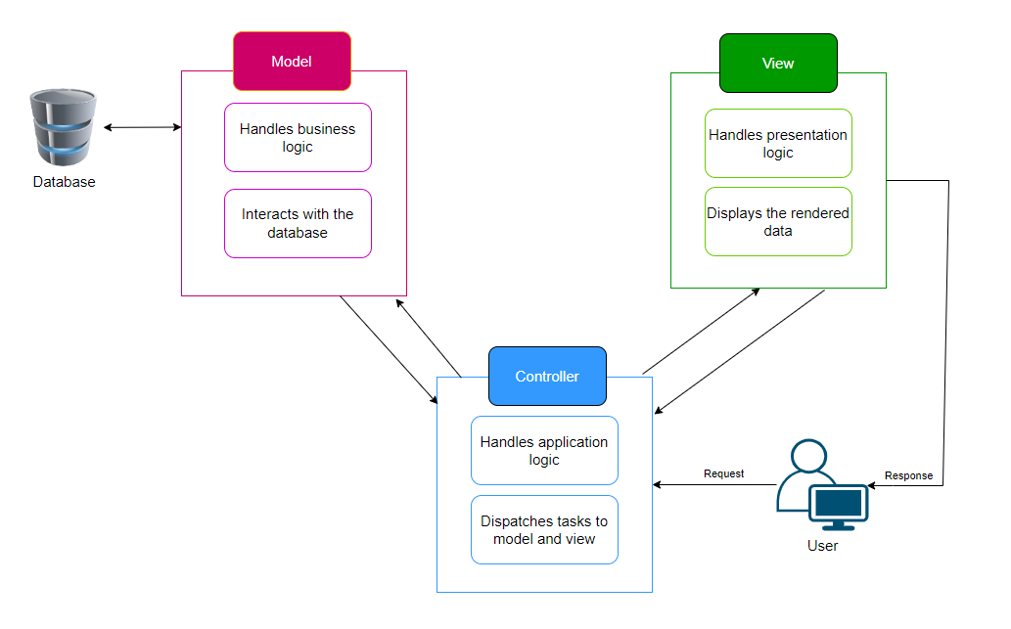By using software architecture patterns, developers can create more maintainable and testable systems that are easier to understand and evolve over time. Additionally, these patterns also enable developers to divide the complexity of the system into smaller, more manageable parts, which allows for more efficient and predictable development and testing.  
  
In our system, we use the model-view-controller (MVC) software architectural pattern to separate application concerns into three components: the model, the view, and the controller

A Model represents the business logic of an application, handling data and making decisions based on it.

The models will be as follows:

* The user model would represent an individual user of the application and would contain information such as the user's username, email, password, and other relevant data. It could also contain methods for authentication and authorization, such as checking if a user's password matches the stored hash or determining if a user has a certain role or permission.
* The profile model would represent a user's profile and would contain information such the profile name, age, bio, and other relevant data will be text at the user's discretion. A practice results model could also be incorporated into this model, allowing each profile to be associated with multiple practice results.
* The practice results model would represent the outcome of the user's practice by including date, score, and other relevant data.

The multiple profiles feature allows each user to have a number of profiles, and each profile is associated with one particular user. this relationship is managed through a one-to-many relationship between the user model and the profile model, in which each user can have a number of profiles, but each profile is associated only with one user.

A View represents the presentation logic - the user's interface - which displays data and facilitates interaction between the user and the program.

In our system, user profiles, practices, results, and other relevant data are displayed to users using the view component. HTML, CSS, and JavaScript would be rendered for the user interface in this view, such as listing the user's profile details or displaying the results of a specific practice.

Further, the view could handle pagination, filtering, sorting, etc., to make information more accessible.

Models and Views are connected by a Controller which controls the application logic, updates the Model based on user input, and retrieves data from the Model to be displayed by the View.

The view would also handle user interaction, accepting input from the user and passing it along to the controller. For example, the view might include a form for creating a new profile, which the user fills out and submits. When the controller validates the input, the new profile will be added to the model.

The MVC architecture separates the concerns of the application into distinct components, allowing the application to be more modular and easier to maintain. It is a common architecture used in web development for creating scalable and maintainable applications.

## 7. Evaluation and Verification Plan

### 7.1 Evaluation

Product evaluation will be based on its ability to be an efficient and intuitive tool for creating training and tracking the data associated with it.

We tracked the training by saving screenshots and the pace and accuracy metrics we discussed earlier.

Each profile in the system will have its own indicators, which will appear on dedicated pages.

Our goal is to provide a technological tool to its users, which will allow for the conversion of what is written by hand - whether it is written on a page or on the graphic tablet itself (depending on the model) - so that users will not experience a negative change from what they would experience when writing on a regular page.

Moreover, to ensure a quality user experience, the ability to give feedback from within the system will be added so that end users can give feedback and provide an authentic evaluation of their experience.

Generally, the goal is to create an infrastructure for users and occupational therapists in order to facilitate the therapeutic procedure that the children go through, so that their results will eventually improve and even be an indication of potential future technological developments.

### 7.2 Verification

The diagrams we characterized and the list of requirements we wrote will help us verify the reliability of our final product.

A table of tests will be created as we follow them, and unit tests will be performed for each part as we move into the second phase of the project.

As part of the test plan, we will also perform end-to-end testing for all the system's processes.

In order to implement the tests, we will use the Jest framework mentioned earlier.

|  |  |  |  |
| --- | --- | --- | --- |
|  | Test Subject | Test Headline | Expected Result |
| 1 | **Registration and Login** | Google Sign-In registration | Move to the correct screen after receiving success and the user token from the Google API. |
| 2 |  | Utilize Google Sign-In to access the site | Move to the correct screen after receiving success and the user token from the Google API. |
| 3 |  | Registration using a regular registration form is successful | Move to the correct screen after creating a new User token in the database. |
| 4 |  | Successfully logged in with regular login | Move to the correct screen after receiving the User token from the database. |
| 5 |  | A failure to register using the regular registration process | Display an error message based on the data received from the user |
| 6 |  | Failed to log in using regular login | Display an error message based on the data received from the user |
| 7 | **Profile creation** | The patient profile has been successfully opened by the user | An associated profile will be added to the database, and a confirmation message will be sent to the user |
| 8 |  | A failed attempt has been made to open the patient profile by the user | Display an error message based on the data received from the user |
| 9 | **Profile Selection** | Using the user's profile list, a patient profile is selected | Setting up the profile screen so that practices or data can be selected |
| 10 | **Letter Practice Selection** | Letter training selected by the user | A list of letters will be displayed on the screen and you can select a specific one |
| 11 |  | The user writes the letter in the wrong order | The user will receive immediate feedback at the point where he needs to write next. |
| 12 |  | Selecting a letter from the list was done by the user | The practice consists of a page of lines with duplicates of the selected letter on each |
| 13 |  | A successful pass has been made by the user on the letter | As a result of success, the user will receive positive feedback |
| 14 | **Handwriting organization practice selection** | Handwriting organization practice selected by the user | Setting a maximum space between letters and a minimum writing per line will be displayed before presentation |
| 15 |  | During the settings process, the user entered invalid numbers | Display an error message based on the data received from the user |
| 16 |  | Setting up the initial settings is successfully completed by the user | On the screen will appear a page of rows |
| 17 |  | While writing, the user deviates from the line | The user will receive immediate feedback at the point where he deviated from the line |
| 18 |  | As the user writes, the location of the previous writing is too far away from the current location | The user will receive immediate feedback at the point where he needs to write next. |
| 19 |  | In the next line, the user writes before he reaches the lower limit of writing in the previous line | The user will receive immediate feedback at the point where he needs to write next. |
| 20 | **End Practice** | Practice is completed by the user | A screenshot of the practice is taken |
| 21 |  | On the basis of the practice data, a calculation is made | Data is displayed on the screen |
| 22 |  | The done practice button has been pressed | Upon saving, the information is transferred to a database and the profile page is displayed |
| 22 | **Review of the profile report** | User clicks on a profile associated with him to view a report of that profile | The past data and screenshots from a profile's activities will be displayed in accordance with its practices |
| 23 | **Sign out** | Sign out of the system by the user | Users' data cannot be accessed until relogging, back to the login screen. |

## References

[1] Dinehart, L. H. (2015). Handwriting in early childhood education: Current research and future implications. *Journal of Early Childhood Literacy*, *15*(1), 97-118.

[2] Keifer, J. J. (2015). *Handwriting and fine motor skill development in the kindergarten classroom* (Doctoral dissertation, Texas Christian University).

[3] Graham, S., Harris, K. R., & Adkins, M. (2018). The impact of supplemental handwriting and spelling instruction with first grade students who do not acquire transcription skills as rapidly as peers: A randomized control trial. *Reading and Writing*, *31*(6), 1273-1294.

[4] Hassan, B. A. (2001). The Relationship of Writing Apprehension and Self-Esteem to the Writing Quality and Quantity of EFL University Students.‏ ‏

[5] ‏Rosenblum, S., Weiss, P. L., & Parush, S. (2004). Handwriting evaluation for developmental dysgraphia: Process versus product. *Reading and writing*, *17*(5), 433-458.

[6] Association of Occupational Therapists Of Ireland

[7] Rosenblum, S., Aloni, T., & Josman, N. (2010). Relationships between handwriting performance and organizational abilities among children with and without dysgraphia: a preliminary study. *Research in developmental disabilities*, *31*(2), 502–509. <https://doi.org/10.1016/j.ridd.2009.10.016>

[8] Case-Smith J. (2002). Effectiveness of school-based occupational therapy intervention on handwriting. American Journal of Occupational Therapy, 56, 17–25‏

[9] https://p5js.org/

[10] <https://www.lwtears.com/solutions/writing/handwriting-without-tears>

[11] <https://www.wacom.com/en-us/products/pen-tablets/wacom-intuos-pro>

[12] https://my.clevelandclinic.org/health/diseases/23294-dysgraphia

[13] https://www.learningprintable.com/writing-worksheets-tracing/

[14] https://pixabay.com/